Hi! For GA customer release notes in September, can I give you some additions to make? Absolutely! ☺️
great!
App Studio enhancements:
App Studio: Move/Copy Cards
The Move/Copy functionality from Dashboards is now available in App Studio. Access it via the three-dot menu in the right panel to move or copy cards between pages.
App Studio: Card Location Visibility
The card details info icon, which shows users where a card is located, now also displays the App Studio pages the card exists on. This info icon now also exists on the right panel next to the card name.

Excellent! Any screenshots for these?

I can dig those up!

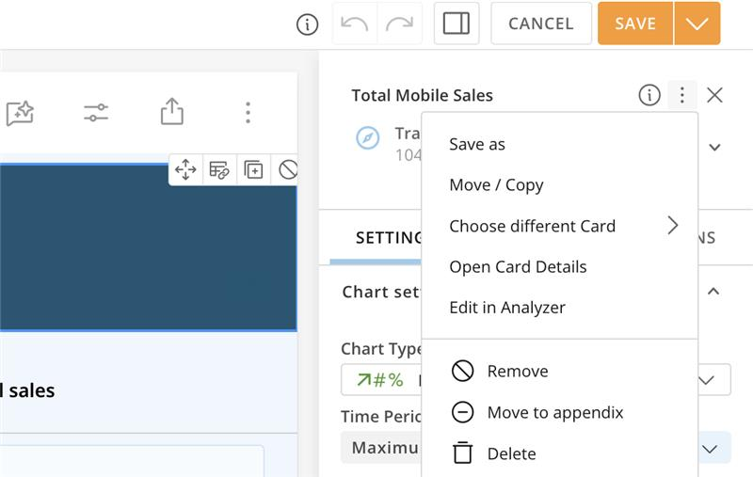
Move/copy (above screenshot for)

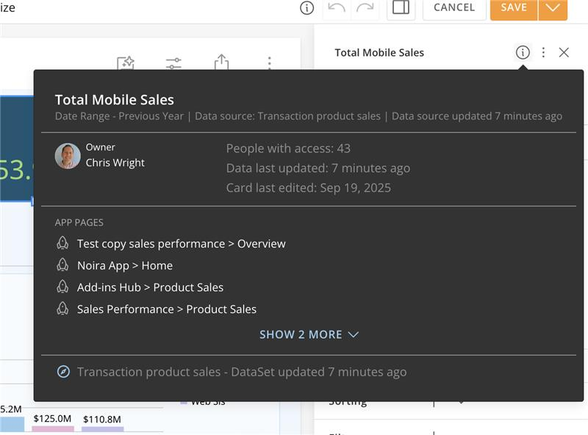
info icon card visibility (above screenshot for)

Awesome! Thank you, Khushboo! I'll make sure these are included for September.

